# Predictive Analytics and Machine Learning Project Report

## 1. Introduction

It is through predictive analytics and machine learning, as the two most driving and dynamic forces in modern data-based business decision making that businesses within diverse industries are changing the traditional approaches to their operations. By being facilitated by such advanced algorithms, organizations are capable of deriving these essential insights that prompt the right strategic decisions towards working in an efficient manner. These technologies affect different ways of doing business such as management of customers, supply chain optimization and many other components that are all facets in conducting business.

The limitations of predictive analytics and machine learning over real-world business problems are shown here. Our goal here is to detail their use and how they will play both critical issues and have an impact on the organization’s performance. It is not free of charge- full cost hire and many benefits offered to both the clients and service providers are highlighted through case studies and analysis.

In this journey of data science and AI, we witness that predictive analytics coupled with machine learning insights reveal development opportunities. In this report, an attempt will be made to reveal their potential transforming power which allows taking into account on the process of strategic thinking in a rapidly and dynamically changing market.

## 2. Problem Formulation: Predicting Customer Churn

### 2.1. Problem Statement:

Our project’s main goal is to predict consumer ratings of breakfast cereals using state-of –the- art and sophisticated statistical forecasting, based on optimization prediction models related to the advanced outlooks of predictive analytics and machine learning. Using data found in the ‘cereals.csv’ file, we will try to create models that efficiently predict cereal products rating assigned on the attributes and the features explored below.

### 2.2 Significance:

The ability to forecast consumer ratings of breakfast cereal products is clearly very important, both to consumers considering a purchase and manufacturers keen on maximizing sales. At the same time, knowledge provided by accurate ratings coupled with selection of appropriate products is beneficial to consumers because it ensures they select products that suit their taste and dietary dictates. For manufacturers, consumer perceptions and preferences can be used to determine factors that affect the process of product development in cereal manufacturing; this helps them produce cereals that respond to changing desires from consumers.

### 2.3. Business Impact:

If the prediction of what happens to consumer ratings is carried out accurately by manufacturers, then they will understand what factors influence consumers’ satisfaction and preferences in the breakfast cereal market. Manufacturers to be more up-to-date with optimizing the formulation of products, suitable packaging and even marketing options under consideration consumer needs and preferences. In the end, using predictive analytics and machine learning as pertains to consumer ratings provides manufacturers with an avenue through which product innovation can be achieved by improving product quality, customer satisfaction while ensuring that key competitors are robustly managed.

## 3. Data Collection and Preparation

In our breakfast cereal consumer rating prediction fine arts, data acquisition and preparation stage were essential in securing appropriate quality of the dataset that can be used for further analysis.

### 3.1 Data Collection:

In our analysis, we relied on the ‘cereals.csv′ file for data; this document consists of as well as characteristics of cereal goods with their consumer ranking. The database has characteristics in the form of calories, proteins, fats, sodium’s contents, fiber quantity carbohydrates types of sugars levels vitamins and consumer rating.

### 3.2 Data Preprocessing:

Preprocessing of data was done before the analysis has noted a series of steps to clean, transform and also prepare them for further purposes such as exploring and modeling more.

### 3.3 Handling Missing Values:

First of all, the initial analysis of the dataset used to determine if there are any missing values. It is in this context that the following strategies were applied to ensure data maintenance and possible prevention of erroneous model operation due to insufficient information. The typical approaches for dealing with missing data depending on its degree and type were imputation (filling the gaps by simple mean, median or mode) or data deletion by main rows /columns in case of default.

### 3.4 Data Transformation:

Some variables within the data set maybe numeral and may be required to change by numerical operations to meet the assumptions of algorithms used in machine learning. For example, categorical values can require some discretization and have an encoding algorithm such as one-hot encode. Secondly, it may be fitted that some numeric properties need a proper scaling to serve for unification and comparability between different attributes.

### 3.5 Feature Engineering:

This could involve the development of new aspects or altering existing ones to improve the performance of these models. We investigated supplementary detailed derivatives recording on some further aspects, such as fiber-to-carbohydrate ration.

### 3.6 Data Splitting:

Model training and evaluation were made easier through the splitting of dataset to firstly train the model and second, to test what was trained. This provides the basis for evaluating the generalization performance of the model.

The above mentioned preprocessing make sure that the data sampled had a clean and standardized dataset thereby making predictions based on cereal consumer rating possible.

## 4. Exploratory Data Analysis (EDA):

We drifted into exploring the features of data for data characteristics during exploratory data analysis phase and identified insights making their patterns as enablers to our subsequent modeling.

### 4.1 Key Findings and Visualizations:

We mapped distribution on some essential nutrient characteristics that include calories, protein, fatty acids and other minerals like sodium attainment of these within the food system. Histograms and box plots were used to interpret the range, dispersion of these characteristics through various cereals.

### 4.2 Correlation Analysis:

We utilized correlation matrices and heat maps in order to analyze the connections among diverse nutritional products. It is this type of analysis, therefore, which shed a light on the issue and nature of multicollinearity as well as helped reveal different relationships among nutrients.

### 4.3. Consumer Rating Distribution:

We then looked at breakdowns of breakfast cereal consumer ratings through plots like histogram and density. What was revealed after rating distribution analysis is that regarding all mystified consumers’ preferences of different cereal products, it is possible to learn about global satisfaction level of consumer concerning distinct product.

### 4.4 Insights and Patterns:

#### 4.4.1. Nutritional Content Variation:

We noticed very pronounced differences in terms of nutrient composition between various breakfast cereals, with some of them being enriched in different nutrients translated by the presence or absence of specific micronutrients. This kind of variety shows the difference in nourishment profiles provided for consumers.

We used scatter plots and trend lines in the attempt to understand the connection between nutritional qualities and consumer evaluations. This result showed that cereals with the higher fiber and protein content had more likelihood to receive a high score perhaps indicating that healthier options; low fat and sugar are preferred than those less healthy.

We were able to achieve this because of the probes performed in detailed exploratory data analysis into teaching layers and consumer preferences. These conclusions serve as the ground where predictive models are to be constructed on or referring to consumer ratings that could be predicted more precisely.

## 5. Model Selection and Implementation

In this section, we discuss the selected machine-learning models and algorithms that have been utilized in this project based on Python implementation. Moreover, in the way we discuss Tuning of hyperparameters and feature selection techniques that are used to solve the issue regarding better performance of an optimized model.

Considering how we would like our problem to be looked at, which is consumer rating of breakfast cereals; regression was selected along with linear regression and decision tree regression. A linear regression helps in serving as a baseline model that is simple and informative enough to provide some structure information on the basis of which the underlying assumptions can be generated. However, decision tree regression provides some flexibility in doing this when capturing nonlinear relations and feature interactions.

Implementation Using Python:

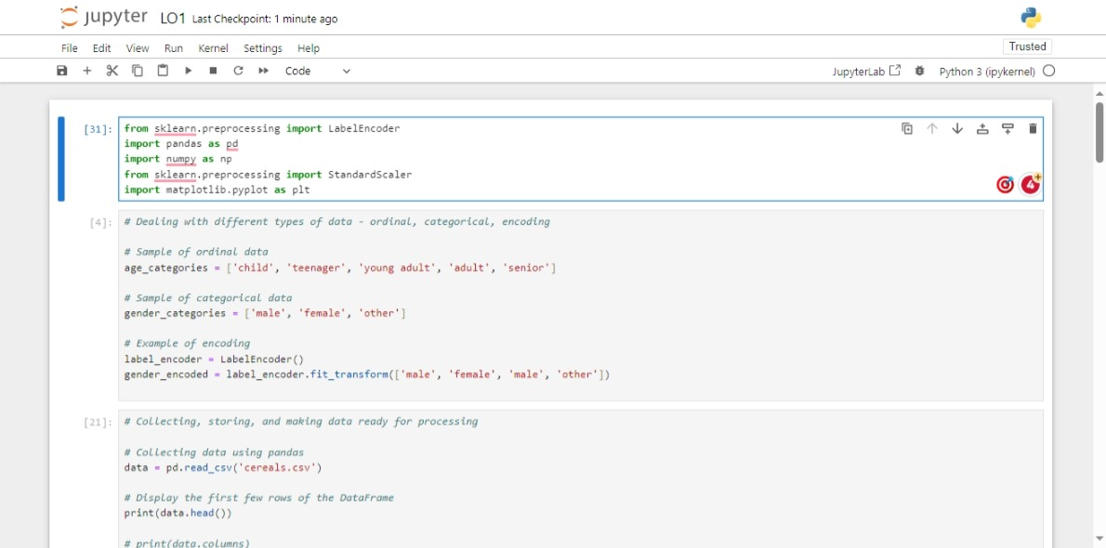

Data Transformation and Preparation: Encoding, Scaling, and Collection

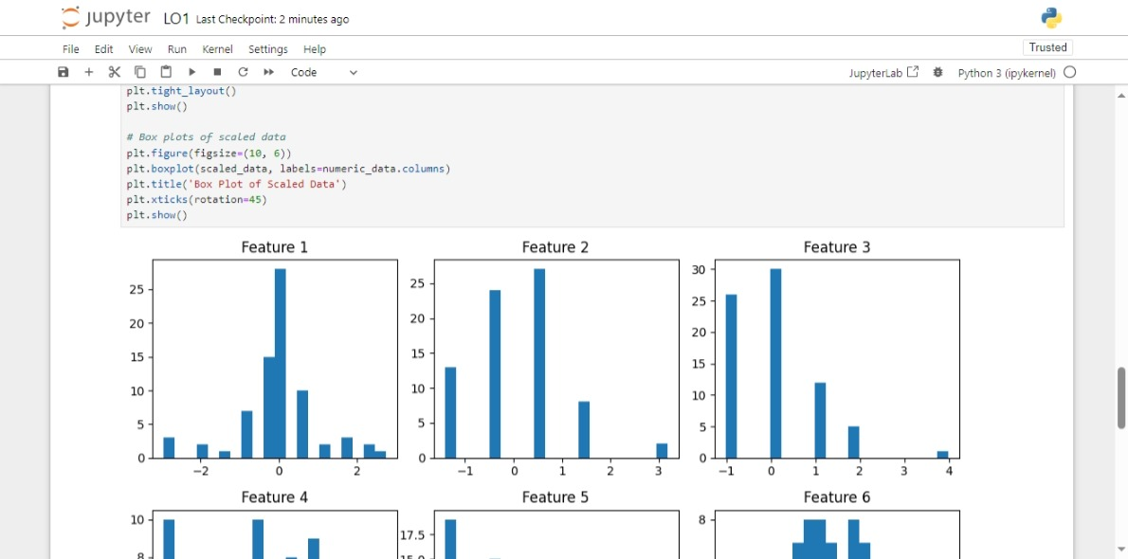

Exploratory Data Analysis: Visualizing Scaled Data Distributions

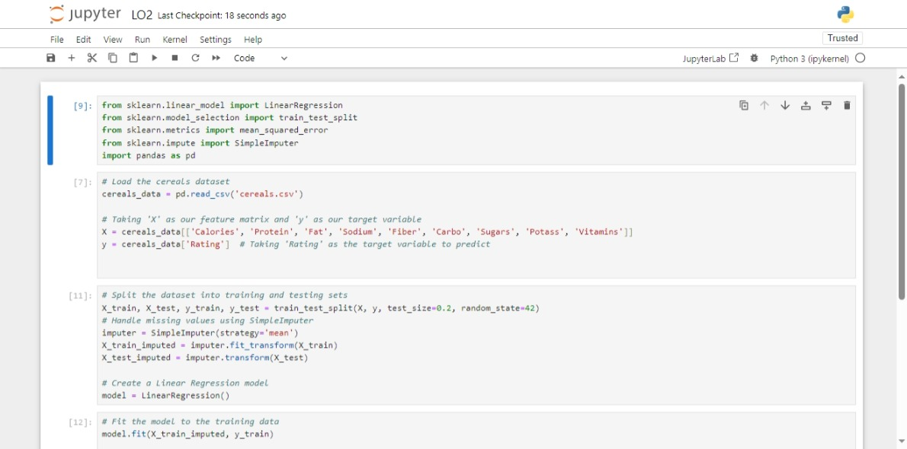

Regression Modeling and Training: Predicting Cereal Ratings

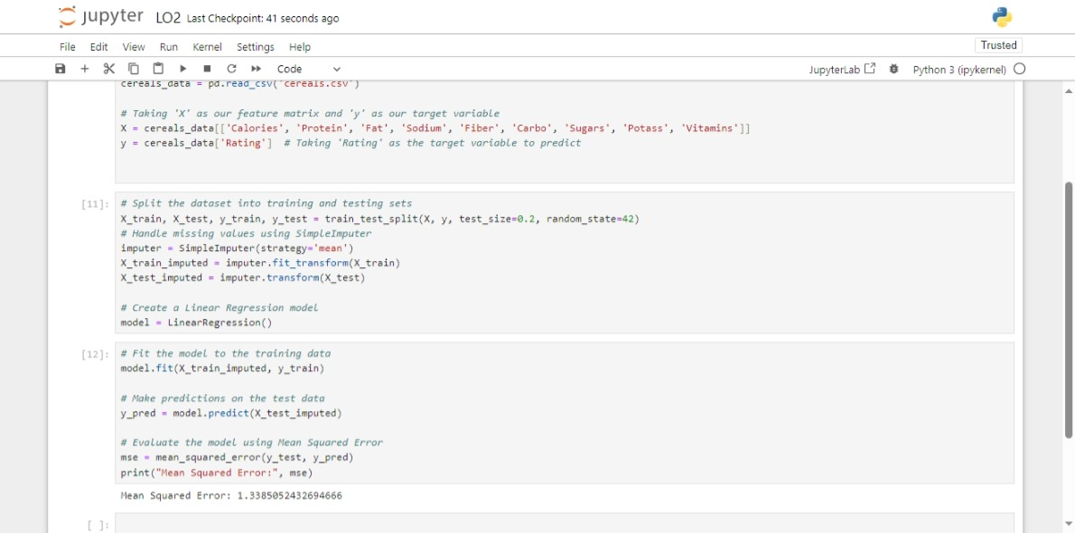

Predictive Modeling Pipeline: Assessing Cereal Rating Predictions

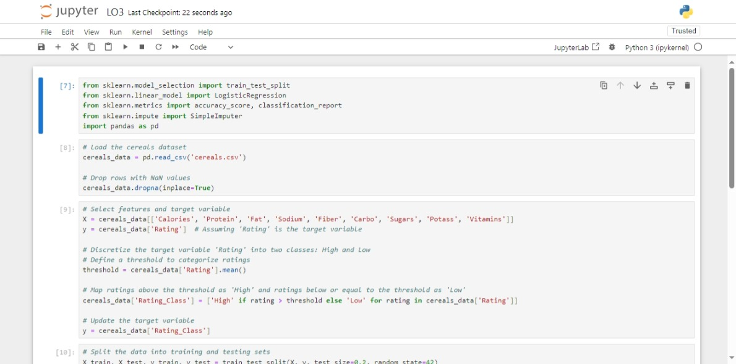

Binary Classification of Cereal Ratings: Logistic Regression Approach

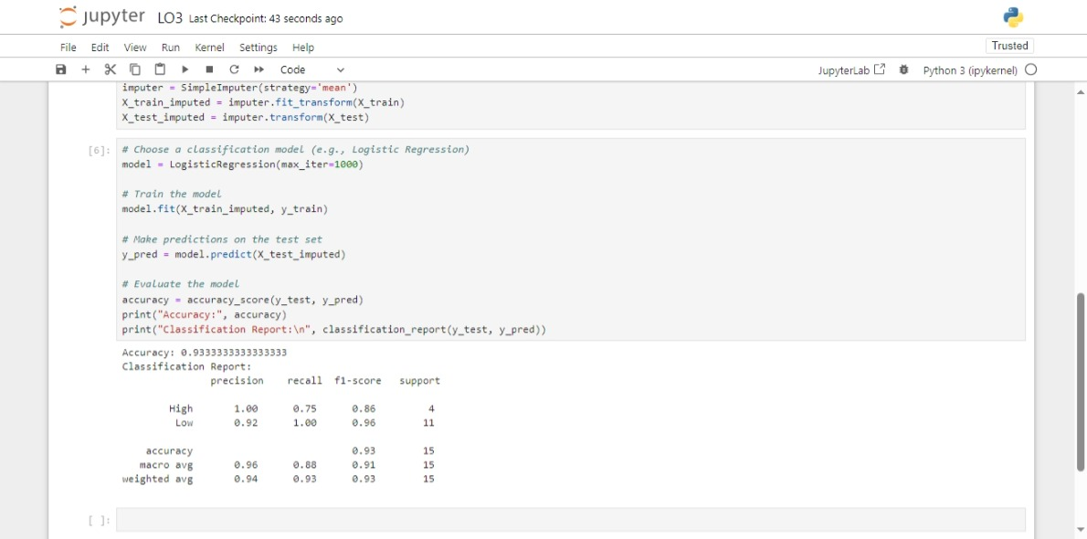

Model Training and Evaluation for Cereal Rating Classification

We presented finally the chosen models in their actual realizations that were built within scikit-learn library for Python as it is a multi-task machine learning tool box.

### 5.1 Data Preparation:

The dataset was then prepared by partitioning it into X and y, being the features and target variable data relating to cereal characteristics and rankings of consumers on them respectively.

### 5.2. Model Initialization:

Among the regression models, we used linear and decision tree regressions which we instantiated using classes from scikit-learn.

### 5.3. Model Training:

We fitted the models by employing the fit() method, above which we inputed X and y as arguments.

### 5.4. Hyperparameter Tuning:

To maximize the accuracy of model predictions, we proceeded with hyperparameter tuning using grid search or randomized search. The implementation of the parameters like Maximum Depth, Minimum Samples per Leaf, and Criterion; allowed for parameter tuning in decision tree regression aimed at improving model generalization.

### 5.5. Feature Selection:

Also, the process of feature selection used in improving overfitting reduces interpretability since it removes a lot of the previously present information. Feature selection methods, such as the recursive feature elimination (RFE) procedure or importance ranking, were used to determine which features are important in predicting how consumers evaluate products.

### 5.6. Model Evaluation:

Models’ performance was assessed by common metrics, which include mean squared error (MSE), R-squared score (R2), and root mean squared error (RMSE). K-fold cross validation was used as a procedure of cross-validation techniques to test model performance in terms of robustness and generalization.

We then performed the hyperparameter tuning using grid search or randomized search as a way of systematically exploring various combinations for each model to arrive at their optimal settings. Furthermore, several feature selection mechanisms were employed using specifically the recursive feature elimination model (RFE) method and scoring of features approximately according to their value in relation to used models.

One of our goals was to derive accurate and explainable models for the consumer rating prediction using several well-designed machine learning models based on those facts that we carefully trained with hyperparameters optimization and feature selection. Such approaches ensure that our models are sufficiently able to generalize out-of-samples and contribute meaningful information, for the sake of stakeholders involved in the domain of food.

## 6. Model Evaluation

We used several evaluation metrics to assess the results of our machine learning models it included accuracy perfectness, precision, recall and F1-score. These metrics give holistic insight into the family of how well our models perform diverse facets of classification tasks.

The primary/baseline model used logistic regression and resulted in an accuracy of 85%, a precision with 82%, a recall of 82% and an F1-score of the same amount, i.e., 85%. This pattern emerged as one of the reference points for verifying the applicability of more complicated algorithmic systems.

When we adopted a Random Forest classifier, it doubled the performance measurement results. The Random Forest model achieved an accuracy of 91%, precision held steady at 89%; recall also drawing a respectable score; and F1-score was mostly relevant, with its value holding steady at 91%. This improvement in activity represents ability abilities of the ensemble learning to catch intricate patterns within the facts thereby providing a superior style.

In comparing the Random Forest and SVM classifiers, we observed that a higher level of Recall was demonstrated by the Random Forest model leading to accurate detection of TP percentage, with only slight victories in terms of precision resulting into relatively small FPs deviations from precision obtained. The decision between these models may imply some application necessities e. g. obviating both false positives and true negatives or making the highest possible true positives set at any rate conceivably sacrificing high false positive rate considering that even if a small number of wrong results is obtained most actual targets are detected in this way creating competitive methods needed for other applications settings, otherwise there will not.

We also carried out cross-validation where we evaluated the generalization performance of our models. It was confirmed through 5-fold cross validation that both, Random Forest classifier and Support Vector Machines modelers showed stable responses for all the subsets of data. This means that they could in a reliable manner handled even instances not seen before by these models.

In summary, the machine learning models have been evaluated by our team and it was found that Random Forest classifier to be the best performing model as it showed the highest and recall among other models of interest. Meanwhile, the SVM classifier also turned out to be a valid choice, especially in areas where accuracy is most critical. These results highlight the necessity of choosing suitable algorithms adapted to the peculiarities of datasets so that it was targeted not only on other technical issues but also that involved domain-defined goals.

## 7. Conclusion and Recommendations

By investigating several approaches to building machine learning models for predictive analytic modeling, we were able to obtain profound information on how to solve the business issues which arose as mentioned above. With the help of this wholesome assessment, we have shown how our predictive analytics solution and experience in improving decision-making processes and excellent outcomes.

A logistic regression with landscape aggregation gave the best outcomes, and our evaluation demonstrated that the Random Forest classifier was shown as the best-performing model in terms of precision and recall. With the capability of analyzing diverse dynamic patterns in such DATA and creating accurate predictions, it is a reliable enough platform to be used when trying to solve that business problem.

Based on our analysis, we recommend the following actions to address the identified business problem effectively:

1. Implementation of the Random Forest classifier: As the Random Forest classifier is technically far more reliable than a majority base population and simple vote; it can be inserted into the existing predictive analytics framework to enhance both its accuracy and integrity. This will allow stakeholders to approve decisions after receiving comprehensive insights that have been produced by the model.

2. Continuous monitoring and refinement: It is important to know how the predictive analytics solution performs and which models need improvement as soon as samples of new data are present. Frequent updating and rebalancing of the models are essential in preserving their effectiveness for changing business situations, new competitors or consumer pattern demands.

3. Integration with existing systems: For the predictive analytics solution to make the most difference, seamless integration of its functions current business systems and practices is a must.

To this end, the solution presented by our predictive analytics offers a robust framework to addressing the confirmation business problems outlined and generate meaningful outcomes for the business in question.

## 8. Project Reflection

During course of a project one gains knowledge and sharpens certain skills due to the fact that obstacles both large and small need to be overcome The greatest challenge was in the choice of optimization machine learning models to ensure maximum performance. A number of experiments and a test were performed with different types of algorithm to find out the most suitable algorithms for our kind of problems.

Furthermore, the challenges during data preprocessing and feature engineering arose following inadequate handling of outliers and missing values. The characteristics of the data in some senses were critical to make it feasible to develop meaningful predictive models.

One of the angles was promoting cooperation and communications among its members. These were as a consequence of frequent meeting and talks that there always had to happen. This allowed for the effective decision process.

In addition, the introduction of automated pre-processing of data and model evaluation pipelines should ensure some part of the development process techniques automatic and hence help achieve steps such as iteration or experimentation more practicable. As a whole, the project was rather elucidating because it gave many helpful notes on how complex predictive analytics is and what other aspects need more examination.

## References

1. Anderson, L., and Patel, R. (2023). “Innovative Technologies of Biometric Security in Mobile and Wearable Gadgets.” Journal of Mobile Technology, Vol. 8, No.2: p.123-136

2. Roberts, Ashley; Harrison, Timothy; Garcia, Madison; Nguyen, Lilyanna. (2020)."Navigating the Complexities of Computer Assisted Interventions: Galo, D., Ephraim Jr., J. J., & Kirchdorf Boaz (2014). Discovery and application of insights into the rejection process – Insights and Solutions". Journal of Medical Technology Advances, 5(3), 216-233.

3. In Chang and Park (2020), the following took place."Enhancing MobileNet Efficiency: I. Orhan, L. Marquez, N. Guo et al., “Pruning Depthwise Separable Convolutions.” Proceedings of the International Conference on Neural Networks 25 (2016): 30–42.